

**Capstone Project Report**

**Report 2 – Project Management Plan**

– Hanoi, October 2022 –

**Table of Contents**

I. Record of Changes 3

II. Project Management Plan 4

1. Overview 4

1.1 Scope & Estimation 4

1.2 Project Objectives 6

1.3 Project Risks 7

2. Management Approach 7

2.1 Project Process 7

2.2 Quality Management 8

2.3 Training Plan 8

3. Project Deliverables 8

4. Responsibility Assignments 9

5. Project Communications 9

6. Configuration Management 10

6.1 Document Management 10

6.2 Source Code Management 10

6.3 Tools & Infrastructures 10

# I. Record of Changes

|  |  |  |  |
| --- | --- | --- | --- |
| Date | A* M, D | In charge | Change Description |
| 07/10/2022 | A | HuyenBN | Responsibility Assignments, Project Communications, and Configuration Managements |
| 09/10/2022 | A | AnNT | Overview; Management Approach; Deliverables |
| 09/10/2022 | M | GiangNT | Review all Document; Change “Configuration Management” |
| 16/10/2022 | M | AnNT | Project Process |
|  |  |  |  |
|  |  |  |  |
|  |  |  |  |
|  |  |  |  |
|  |  |  |  |
|  |  |  |  |
|  |  |  |  |
|  |  |  |  |
|  |  |  |  |

*A - Added M - Modified D - Deleted

# II. Project Management Plan

## 1. Overview

### 1.1 Scope & Estimation

|  |  |  |  |
| --- | --- | --- | --- |
| **#** | **WBS Item** | **Complexity** | **Est. Effort**  **(man-days)** |
| ***1*** | ***Login*** |  | **13** |
| 1.1 | ADMIN - ADMISSION - Login with username | Simple | 3 |
| 1.2 | Login with Facebook | Medium | 5 |
| 1.3 | Login with Google | Medium | 5 |
| ***2*** | ***LANDLORD - Sign Up*** |  | **17** |
| 2.1 | Sign Up with Facebook | Medium | 5 |
| 2.2 | Sign Up with Google | Medium | 5 |
| 2.3 | Upload ID Card | Simple | 3 |
| 2.4 | Choose Campus | Simple | 2 |
| 2.5 | Provide Basic Information | Simple | 2 |
| ***3*** | ***GUEST - List of houses*** |  | **36** |
| 3.1 | View List of Available Houses | Simple | 3 |
| 3.2 | Search Available House | Complex | 10 |
| 3.3 | View List of all Houses | Simple | 3 |
| 3.4 | View List of Reported Houses | Medium | 5 |
| 3.5 | House - Room Statistic | Medium | 5 |
| 3.6 | Filter Result | Complex | 10 |
| 3.6.1 | Filter by Type | Simple | 2 |
| 3.6.2 | Filter by Address | Simple | 2 |
| 3.6.3 | Filter by Price | Simple | 2 |
| 3.6.4 | Filter by Distance | Medium | 2 |
| 3.6.5 | Filter by Services | Medium | 2 |
| ***4*** | ***GUEST - House Details*** |  | **19** |
| 4.1 | House basic details | Medium | 5 |
| 4.2 | Maps position | Complex | 8 |
| 4.3 | View House Review | Simple | 2 |
| 4.4 | Available Room List | Simple | 2 |
| 4.5 | Landlord Information | Simple | 2 |
| ***5*** | ***GUEST - Room Details*** |  | **2** |
| 5.1 | View Room Details | Simple | 2 |
| ***6*** | ***GUEST - Review House*** |  | **8** |
| 6.1 | Star Rating | Medium | 4 |
| 6.2 | Comment | Medium | 4 |
| ***7*** | ***Report Violation*** |  | **4** |
|  | Report Violation | Medium | 4 |
| ***8*** | ***LANDLORD - List of Houses*** |  | **3** |
| 8.1 | View List of Houses | Medium | 3 |
| ***9*** | ***LANDLORD - Manage Houses*** |  | **25** |
| 9.1 | Update House Information | Medium | 4 |
| 9.2 | Delete House | Medium | 3 |
| 9.3 | Add New House | Complex | 10 |
| 9.3.1 | Download Templates | Medium | 2 |
| 9.3.2 | Import Data | Complex | 8 |
| 9.4 | Search House | Complex | 8 |
| 9.4.1 | Filter by Status | Simple | 2 |
| ***10*** | ***LANDLORD - Manage Rooms*** |  | **24** |
| 10.1 | Room List | Simple | 2 |
| 10.2 | View Room Details | Simple | 3 |
| 10.3 | Change Room status | Simple | 2 |
| 10.4 | Add Room | Complex | 8 |
| 10.5 | Delete Room | Medium | 4 |
| 10.6 | Update Room Information | Medium | 5 |
| ***11*** | ***LANDLORD - Profile*** |  | **6** |
| 11.1 | View Profile | Simple | 2 |
| 11.2 | Update Profile | Medium | 4 |
| ***12*** | ***ADMIN - Manage Staff Account*** |  | **18** |
| 12.1 | Change Password | Medium | 4 |
| 12.2 | Staff List | Simple | 2 |
| 12.3 | Create Staff Account | Medium | 5 |
| 12.4 | Change Active Status | Simple | 3 |
| 12.5 | Reset Password | Medium | 4 |
| ***13*** | ***STAFF - Landlord Sign Up Request*** |  | **6** |
| 13.1 | View Sign Up Request | Simple | 2 |
| 13.2 | Approve/Reject Sign Up Request | Medium | 4 |
| ***14*** | ***STAFF - Manage Landlord Account*** |  | **8** |
| 14.1 | Landlord List | Simple | 2 |
| 14.2 | Landlord Details | Medium | 4 |
| 14.3 | Change Active Status | Simple | 2 |
| ***15*** | ***STAFF - Manage Houses*** |  | **12** |
| 15.1 | View List of House | Simple | 2 |
| 15.2 | Filter list | Complex | 6 |
| 15.2.1 | Filter by Area | Medium | 3 |
| 15.2.2 | Filter by Availability Status | Medium | 3 |
| 15.3 | View List of Reported House | Medium | 4 |
| 15.3.1 | Change Active Status | Simple | 2 |
| 15.3.2 | List of Reports | Simple | 2 |
| ***Total Estimated Effort (man-days)*** | | | ***201*** |

### 1.2 Project Objectives

|  |  |  |  |  |  |
| --- | --- | --- | --- | --- | --- |
| **#** | **Testing Stage** | **Test Coverage** | **No. of Defects** | **% of Defect** | **Notes** |
| 1 | Reviewing | 100% | 20 | 45% |  |
| 2 | Unit Test | 100% | 9 | 20.5% |  |
| 3 | Integration Test | 100% | 9 | 20.5% |  |
| 4 | System Test | 100% | 3 | 7% |  |
| 5 | Acceptance Test | 100% | 3 | 7% |  |

**Milestone Timelines (%): 100**

**Allocated Effort (man-days): 201**

### 1.3 Project Risks

|  |  |  |  |  |
| --- | --- | --- | --- | --- |
| **#** | **Risk Description** | **Impact** | **Possibility** | **Response Plans** |
| 1 | Miss Deadline | Severe | High | Working over time |
| 2 | Requirement Change | Severe | Medium | Adjust Task and Schedule |

## 2. Management Approach

### 2.1 Project Process

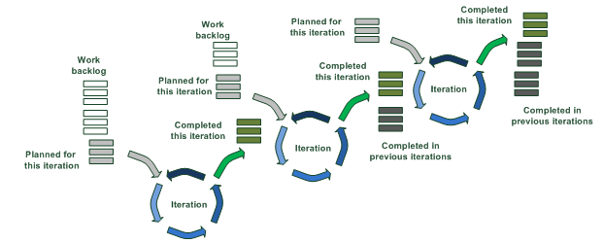

The project is developed using the combination of Incremental Model and Iterative Model. Project requirements is divided into multiple standalone modules of software develop cycle. Each module goes through the requirements, design, implementation, and testing phase. Each subsequent release of the module adds function to the previous release. The process continues until the complete system achieved.

Some Definition:

- Work backlog is a list of parts of requirements for each phase

- An Iteration is a software develop cycle. Each iteration contains stages of requirements (if necessary), design, implementation, review (if necessary), testing, and deploying.

### 2.2 Quality Management

To improve the quality of the project, these approaches are included:

* Defect Prevention
* Unit Testing
* Integration Testing
* System Testing
* Acceptance Testing

### 2.3 Training Plan

|  |  |  |  |
| --- | --- | --- | --- |
| Training Area | Participants | When, Duration | Waiver Criteria |
| Angular 12 | All Member | 11/09/2022 - 17/09/2022 | Mandatory |
| Git, Github | All Member | 09/09/2022 | Mandatory |

## 3. Project Deliverables

|  |  |  |  |
| --- | --- | --- | --- |
| **#** | **Deliverable** | **Due Date** | **Notes** |
| 1 | Product Vision  Basic Use case  System actors  Report 1 | 10/09/2022 | Initiate Project |
| 2 | Project Scope  Requirements  Business Rules | 15/09/2022 | Customer Meeting  Functional Requirements  Non-functional Requirements |
| 3 | Plan and Schedule  Report 2 | 08/10/2022 |  |
| 4 | System Design  Report 3  Report 4 | 15/10/2022 | Screen Design  Architectural Design  Database Design  Etc. |
| 5 | Sprint 1 | 22/10/2022 | Coding  Unit Testing  Integration Testing |
| 6 | Sprint 2 | 05/11/2022 | Coding  Unit Testing  Integration Testing |
| 7 | Sprint 3 | 19/11/2022 | Coding  Unit Testing  Integration Testing  System Testing  User Acceptance Testing |
| 8 | Sprint 4 | 26/11/2022 | Coding  Unit Testing  Integration Testing  System Testing  User Acceptance Testing |
| 9 | Sprint 5 | 03/12/2022 | System Testing  User Acceptance Testing  Deploy Final Product |
| 10 | Final Report  Final Product  User Guides  Presentation | 10/12/2022 |  |

## 4. Responsibility Assignments

*D~Do; R~Review; S~Support; I~Informed; <blank>- Omitted*

|  |  |  |  |  |  |
| --- | --- | --- | --- | --- | --- |
| **Responsibility** | **GiangNTHE153046** | **HuyenBNHE150346** | **ThongPQHE150340** | **AnNTHE150432** | **KienNTHE150160** |
| Collect Requirements | R,D | D | D | D | D |
| Prepare Project Introduction Document | R,D | I | D | I | I |
| Prepare Project Management Plan | R | D | I | D | R |
| Prepare SRS Document (User Requirements) | R,D | I | I | I | D |
| Create Screen Mockups | R,D | D | D | D | D |
| Design Database | R,D | D | D | D | D |
| Collect Administrative Unit Data | D | I | I | I | I |
| Draw Use Case Diagram | R | D | I | I | I |
| Coge Function Login | R | I | I | D | I |
| Dram Entity Relationship Diagram | R | D | I | I | I |
| Draw Screen Flow Diagrams | D | I | I | I | I |

## 5. Project Communications

|  |  |  |  |  |
| --- | --- | --- | --- | --- |
| **Communication Item** | **Who/ Target** | **Purpose** | **When, Frequency** | **Type, Tool, Method(s)** |
| Daily Meeting | All team members | - Checking progress of assigned tasks  - Finding solutions for difficult problems | 9 p.m everyday | Discord |
| Assign Tasks | All team members | - Project Manager assigns tasks to other team members | Everyday | Jira |
| Weekly Meeting With Supervisor | All team members, supervisor | - Checking progress of project  - Plan upcoming tasks  - Update requirements | Once a week | Offline |
| Meeting with Supervisor and Client | All team members, supervisor, client | - Clarify user requirements, roles & project scope | 16/09/2022  13/09/2022 | Offline |

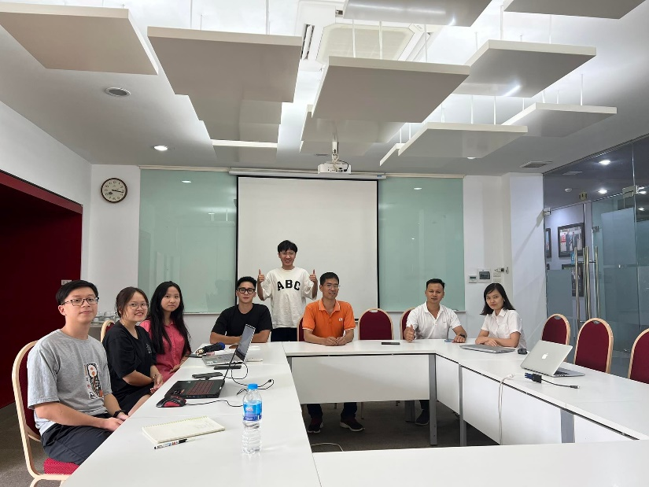  
*Meeting with Supervisor and Staffs of the University (13/09/2022)*

*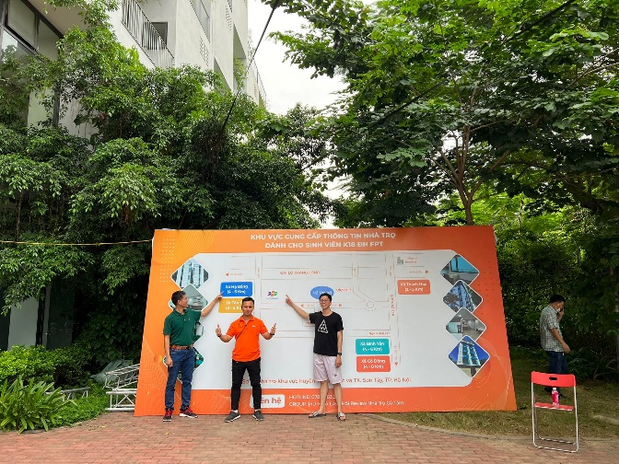 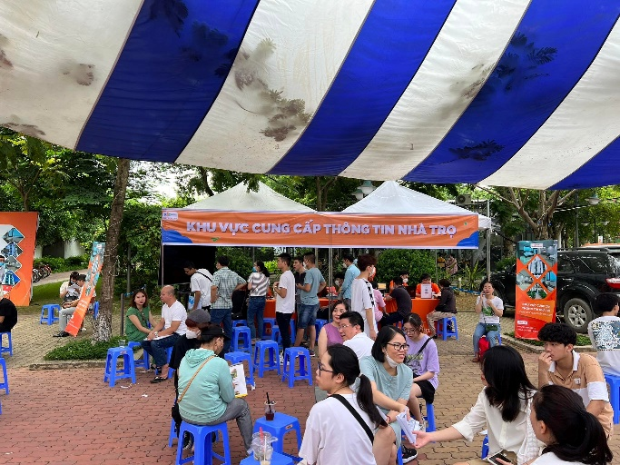  
Meeting at the University’s Enrollment day (16/09/2022)*

## 6. Configuration Management

### 6.1 Document Management

* Management Tools:
  + Google Drive
  + OneDrive
  + GitHub
* Team leader assigns and describes tasks through Facebook & Discords. All Documents will be submitted to management tools to keep track of changes. Team leader then collects them all to submit to the mentor.

### 6.2 Source Code Management

* Management Tools:
  + GitHub
* Team leader assigns and describes tasks through Facebook & Discords. All source code will be pushed to Github for version control. Team leader then pull it back to run on deployment environment.

### 6.3 Tools & Infrastructures

|  |  |
| --- | --- |
| **Category** | **Tools / Infrastructure** |
| **Technology** | Angular 12 (FrontEnd); C# .NET 5 (BackEnd) |
| **Database** | Microsoft SQL Server |
| **IDEs/Editors** | Visual Studio Code; Visual Studio |
| **Diagramming** | DrawIO; Mindmeister |
| **Documentation** | Ms Office;, Google Docs; Microsoft Office |
| **Version Control** | GitHub (Source Codes), Google Drive (Documents); OneDrive (Documents) |
| **Deployment server** |  |
| **Project management** | Jira (Schedule, Tasks, Defects) |
| **UI/UX Design** | Figma |